KFC VIZSGAELEMEK

Topológia:

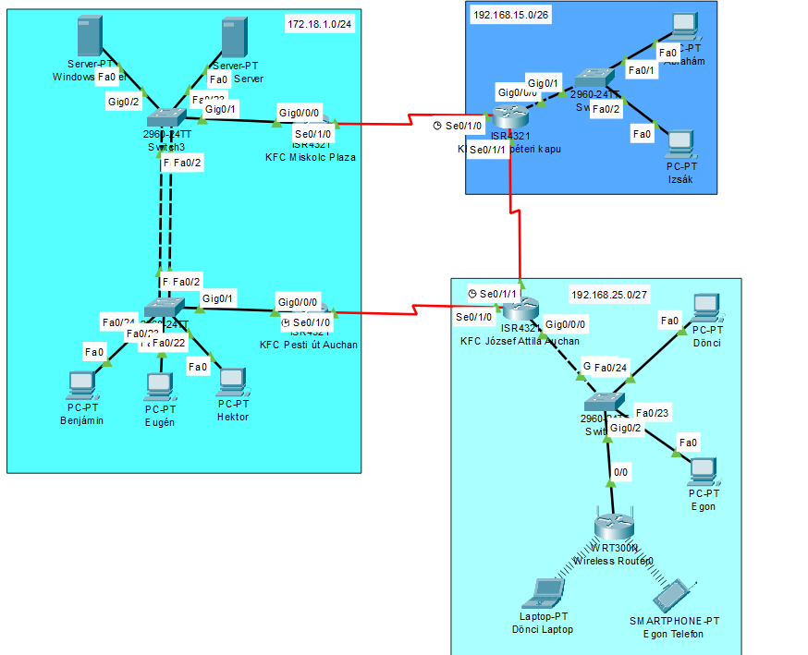

IP cím táblázat:

|  |  |  |  |  |
| --- | --- | --- | --- | --- |
| Név | Port azonosító | IP | Maszk | Gateway |
|  | Serial0/1/0 | 10.10.10.10 | /28  255.255.255.240 |  |
|  | Gig0/0/0.35 | 172.18.1.2 | /26  255.255.255.192 |  |
| KFC Miskolc pláza | Gig0/0/0.45 | 172.18.1.66 | /27  255.255.255.224 |  |
|  | Gig0/0/0.55 | 172.18.1.98 | /27  255.255.255.224 |  |
|  | Serial0/1/0 | 10.10.10.20 | /28  255.255.255.240 |  |
|  | Gig0/0/0.35 | 172.18.1.3 | /26  255.255.255.192 |  |
| KFC Pesti út Auchan | Gig0/0/0.45 | 172.18.1.67 | /27  255.255.255.224 |  |
|  | Gig0/0/0.55 | 172.18.1.99 | /27  255.255.255.224 |  |
| KFC Szentpéteri kapu | Gig0/0/0 | 192.168.15.1 | /28  255.255.255. 240 |  |
|  | Serial0/1/0 | 10.10.10.11 | /28  255.255.255. 240 |  |
|  | Serial0/1/1 | 20.20.20.1 | /28  255.255.255. 240 |  |
| KFC József Attila Auchan | Serial0/1/0 | 10.10.10.21 | /28  255.255.255.240 |  |
|  | Serial0/1/1 | 20.20.20.2 | /28  255.255.255.240 |  |
|  | Gig0/0/0 | 192.168.25.1 | /27  255.255.255.224 |  |
| Windows Server | Fa0 | 172.18.1.62 | /28  255.255.255.240 |  |
| Linux Server | Fa0 | 172.18.1.94 | /27  255.255.255.224 |  |
| Benjámin  PC | Fa0 | DHCP | DHCP | 172.18.1.1 |
| Eugén  PC | Fa0 | DHCP | DHCP | 172.18.1.65 |
| Hektor  PC | Fa0 | DHCP | DHCP | 172.18.1.97 |
| Egon  PC | Fa0 | DHCP | DHCP | 192.168.25.1 |
| Dönci  PC | Fa0 | DHCP | DHCP | 192.168.25.1 |
| Izsák  PC | Fa0 | DHCP | DHCP | 192.168.15.1 |
| Ábrahám  PC | Fa0 | DHCP | DHCP | 192.168.15.1 |
| Egon  Telefon | Fa0 | DHCP | DHCP | 192.168.35.1 |
| Dönci  Laptop | Fa0 | DHCP | DHCP | 192.168.35.1 |

|  |  |  |  |  |
| --- | --- | --- | --- | --- |
| IPv6 Táblázat | | | | |
| Név | Port azonosító | IP | Maszk | Gateway |
| KFC Miskolc plaza | Gig0/0/0.35 | 2001:db8:acad:35::1 | /64 | fe80::35 |
| Gig0/0/0.45 | 2001:db8:acad:45::1 | /64 | fe80::45 |
| Gig0/0/0.55 | 2001:db8:acad:55::1 | /64 | fe80::55 |
| KFC Pesti út Auchan | Gig0/0/0.35 | 2001:db8:acad:35::1 | /64 | fe80::35 |
| Gig0/0/0.45 | 2001:db8:acad:45::1 | /64 | fe80::45 |
| Gig0/0/0.55 | 2001:db8:acad:55::1 | /64 | fe80::55 |
| KFC Szent Péteri kapu | Gig0/0/0 | 2001:db8:acad::1 | /64 | fe80::35 |
| KFC József Attila Auchan | Gig0/0/0 | 2001:db8:acad::1 | /64 | fe80::35 |
| Benjámin | Fa0 | SLAAC | | |
| Eugén | Fa0 |
| Hektor | Fa0 |
| Ábrahám | Fa0 |
| Izsák | Fa0 |
| Dönci | Fa0 |
| Egon | Fa0 |
| Dönci Laptop | Fa0 |
| Egon Telefon | Fa0 |

|  |  |  |  |  |  |
| --- | --- | --- | --- | --- | --- |
| Etherchannel tábla | | | | | |
|  | | Csoport | Mód | Protokoll | Port |
| Eszközök | Switch3 | 1 | Active | LACP | Fa0/1, Fa0/2 |
| Switch2 | 1 | Passive | LACP | Fa0/1, Fa0/2 |

|  |  |  |  |  |  |  |
| --- | --- | --- | --- | --- | --- | --- |
| HSRP Tábla | | | | | | |
| Eszköz | Port | Csoport | Prioritás | Státusz | Készenlét IP | Virtuális IP |
| KFC Miskolc Pláza | Gig0/0/0.35 | 35 | 120 | Aktív | 172.18.1.3 | 172.18.1.1 |
| Gig0/0/0.45 | 45 | 120 | Aktív | 172.18.1.67 | 172.18.1.65 |
| Gig0/0/0.55 | 55 | 120 | Aktív | 172.18.1.99 | 172.18.1.97 |
| KFC Pesti út Auchan | Gig0/0/0.35 | 35 | 110 | Készenlét | Helyi | 172.18.1.1 |
| Gig0/0/0.45 | 45 | 110 | Készenlét | 172.18.1.65 |
| Gig0/0/0.55 | 55 | 110 | Készenlét | 172.18.1.97 |

|  |  |  |  |  |
| --- | --- | --- | --- | --- |
| VLAN Tábla | | | | |
| Eszköz | VLAN Azonosító | VLAN Neve | Portok | Hálózat |
| KFC Miskolc Pláza | 35 | VLAN35 | Gig0/0/0.35 | 172.18.1.0/24 |
| 45 | VLAN45 | Gig0/0/0.45 | 172.18.1.64/27 |
| 55 | VLAN55 | Gig0/0/0.55 | 172.18.1.96/27 |
| KFC Pesti út Auchan | 35 | VLAN35 | Gig0/0/0.35 | 172.18.1.0/24 |
| 45 | VLAN45 | Gig0/0/0.45 | 172.18.1.64/27 |
| 55 | VLAN55 | Gig0/0/0.55 | 172.18.1.96/27 |
| Benjámin PC | 35 | VLAN35 | Fa0 | 172.18.1.0/24 |
| Eugén PC | 45 | VLAN45 | 172.18.1.64/27 |
| Hektor PC | 55 | VLAN55 | 172.18.1.96/27 |
| Izsák PC |  | | 192.168.15.0/26 |
| Ábrahám PC | 192.168.15.0/26 |
| Dönci PC | 192.168.25.0/26 |
| Eugén PC | 192.168.25.0/26 |
| Dönci Laptop | 192.168.25.0/26 |
| Egon Telefon | 192.168.25.0/26 |
| Windows Szerver | 35 | VLAN35 | 172.18.1.0/24 |
| Linux Szerver | 45 | VLAN45 | 172.18.1.64/27 |
| Switch2 | 35 | VLAN35 | Fa0/24 |  |
| 45 | VLAN45 | Fa0/23 |
| 55 | VLAN55 | Fa0/22 |
| Switch3 | 35 | VLAN35 | Fa0/24 |
| 45 | VLAN45 | Fa0/23 |
| 55 | VLAN55 | Fa0/22 |

SSH:

Domain: kfc.hu

user: admin secret: admin

jelszavak:

sima: cisco

secret: class

console: cisco

telnet: cisco

KFC Linux server:

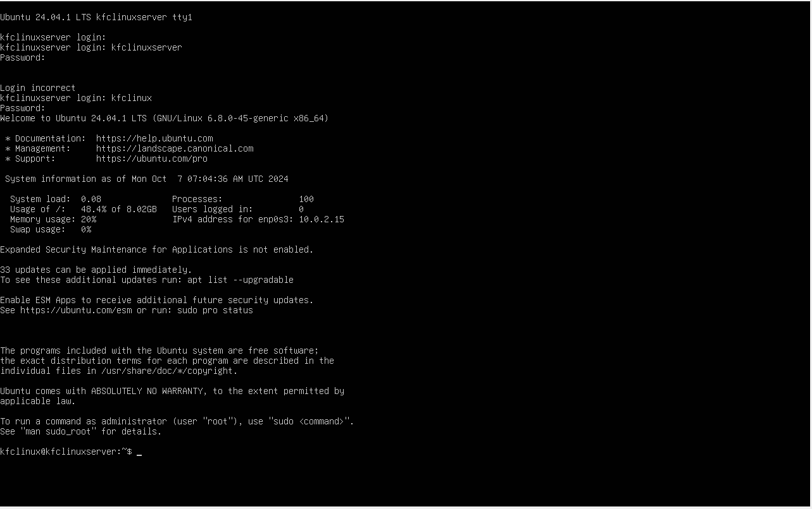

KFC Linux server elindítása